The First Draft Of My Thesis

Summary by myself:
The main topic: in this thesis is action recognition technical, so to talk it well and to tell some one how you study it form zero.
This thesis aims to apply for a patent, since I want to create something new and it is maybe used in our lives in the near future.
Only focus on the accelerometer and Gyroscope of Iphone

Table of Contents
The First Draft Of My Thesis 1
Table of contents 2
Declaration 2
Table of Figures 2
Table of Tables 2
Glossary of Abbreviations 2
Acknowledgements 2
Abstract 2
1 Introduction 2
1.1 Background Information 2
1.2 Acknowledgements 3
2 Accelerometer with steps algorithm 3
2.1 The introduction and working principle of an accelerometer 3
2.1.1 What is an accelerometer 3
2.1.2 Working principle of an accelerometer 3
2.1.3 How an accelerometer works in mobile phone. 5
2.2 The principle of testing steps 6
2.2.1 How an accelerometer works in human body 6
2.2.2 The features of one steps 6
2.3 Key algorithms of recording steps 8
2.3.1 Peak Detection Algorithm 8
2.3.2 Transform Domain Algorithm 9
2.3.3 Threshold Filtering Algorithm 10
2.3.4 Pattern Recognition Algorithm 10
2.4 My pedometer program 11
2.4.1 The program operation 11
2.4.2 The accuracy of results 12
3 Gyroscope with balance racing game 13
3.1 The introduction of Gyroscope 13
3.1.1 What is a gyroscope 13
3.1.2 Working principle of a gyroscope 13
3.1.3 The relationship between Gyroscope and Accelerometer 14
3.2 The racing game with Gyroscope 15
3.2.1 How a gyroscope works in iPhone 15
3.2.2 Get the current orientation of movement of the phone. 16
3.2.3 Calculating the current angle in every axis 17
3.2.4 How a gyroscope works for the racing game 18
4 Glow Stick with Accelerometer and Gyroscope 18

Table of contents

Declaration

Table of Figures
Picture 2.2.1 Working principle of a capacitive accelerometer(Andrea Nisticò)
Picture 2.2.2 Accelerometer Theory & Design
Picture 2.2.3 and 2.2.4 Using a Three-Axis Accelerometer and GPS Module in a Smart Phone to Measure Walking Steps and Distance(Ying-Wen Bai, Chia-Hao Yu and Siao-Cian Wu

Table of Tables

Glossary of Abbreviations

Acknowledgements

Abstract

Introduction

Background Information
(introduce why I want to use gyroscope and accelerometer to create something here, to read some materials and summarize my own words.)
Nowadays, the rapid development of science and technology has brought lots of conveniences to human daily life and one kind of technologies, action recognition technique, starts to permeate every corner of our lives. Maybe you still haven’t noticed it yet, but exactly you have high possibility of using it before. There are some examples of the applications in our daily lives of this technique: health smart watch that help us to recording the steps every day we walk; robots that can simulate some actions of human; racing game that you just need to move your hands to play games. Absolutely, action recognitions technique is not also just those,

Acknowledgements

Accelerometer with steps algorithm

The introduction and working principle of an accelerometer

What is an accelerometer
Wikipedia explains : “An accelerometer is a device that measures proper acceleration. Proper acceleration, being the acceleration of a body in its own instantaneous rest frame, is not the same as coordinate acceleration, being the acceleration in a fixed coordinate system”. Exactly, an accelerometer is not hard to understand and you just need to know it is used to test the physical acceleration, which is taught in high school physics course and is the rate of change of velocity of an object.

  - （reference: Accelerometer Theory & Design）
The accelerometer can be divided into piezoelectric, piezoresistive and capacitive types according to working principle. Different types suit different circumstances, but those techniques are exactly doing the same thing converting a mechanical motion into an electrical signal. Here, we do not need to discuss too deep for the different inner structures of those types, since it does not affect we use it.

Working principle of an accelerometer
As I mentioned before that an accelerometer is used to test the acceleration of an object. What is the acceleration here? Actually it is the change rate of the velocity of an object, and can be described as the ‘a’ in formula: F=-kx=ma, we studied in middle or high school courses.
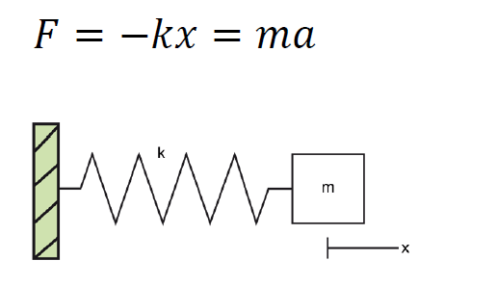
(Picture 2.1.2.1 Working principle of a capacitive accelerometer(Andrea Nisticò))
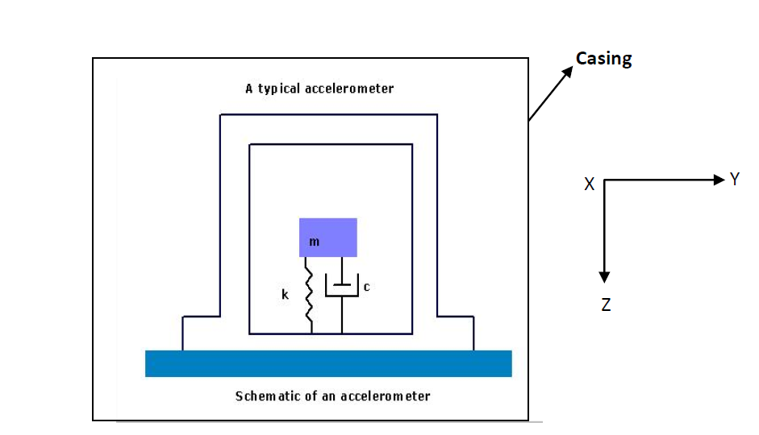
  - (Picture 2.1.2.2 Accelerometer Theory & Design)
As the picture2.2.2 above shows the schematic of an accelerometer, which be comprised of a mass (m), a spring (k) and a dashpot. When the object moves and has an accelerations, the mass moves to another position, the spring (k) will stretches and the dashpot will produce an relative damping coefficient(c) and the value (c) can be transfer to a digital signal or number which can be used directly.

The exact inner structure of an accelerometer is just like this, absolutely not, in our daily life, the most popular type of accelerometers is the Three-Axis Acceleration Sensor such as iPhone installing it. Just as its name implies, the three-axis accelerometer does not only test one direction’s acceleration, but three directions’ accelerations: X, Y and Z.

How an accelerometer works in mobile phone.
Here, we just use the three-axis accelerometer of an iPhone as an example to describe how an accelerometer works in an iPhone.
As we mentioned before, a three -axis accelerometer is used to test three different directions’ acceleration. There are two pictures below, which show three dimensional axis and the acceleration of every axis can be tested by the accelerometer installed in the phone.
And maybe some beginners will ask how to get the three axes data from an iPhone. Exactly, there are lots of app creating the function to catch the efficient data directly from the phone. Introducing one free iPhone APP named “Physics Toolbox Sensor Suite”, which can get not only the data of accelerometer from the iPhone to email to your email box, but also Gyroscope which will be discuss in next chapter and Magnetometer sensor. The data of accelerometer and gyroscope from an iPhone in this thesis is almost caught by this APP.
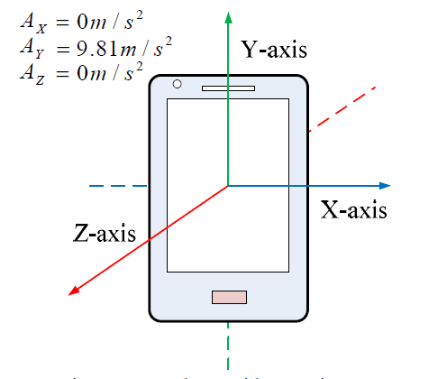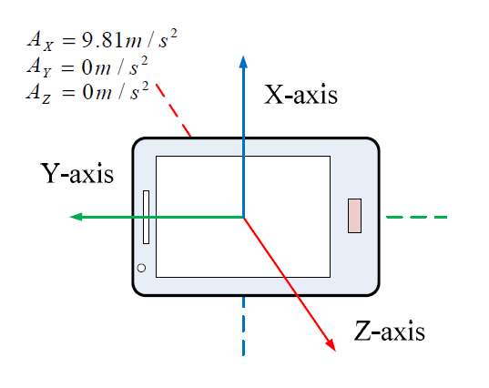
  - (Picture 2.1.3.1 and 2 Using a Three-Axis Accelerometer and GPS Module in a Smart Phone to Measure Walking Steps and Distance(Ying-Wen Bai, Chia-Hao Yu and Siao-Cian Wu))

The principle of testing steps

How an accelerometer works in human body
When a pedestrian is walking on the road, the accelerometer will divide the motion acceleration by three directions, as we can see in the picture 2.2.1.1 below: Vertical Direction, Forward Direction and Side Direction, which can be also called: X, Y and Z Axis.
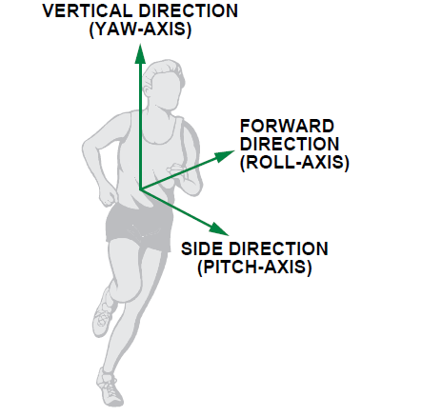
  - (Picture 2.2.1.1 Full-Featured Pedometer Design Realized with 3-Axis Digital Accelerometer)

The features of one steps
There is a swing phase showed in picture 2.2.2.1,which is a step period during people movement. Absolutely, there is a change process of speed of the leg movement during one step period, so we can catch the acceleration using the accelerometer.
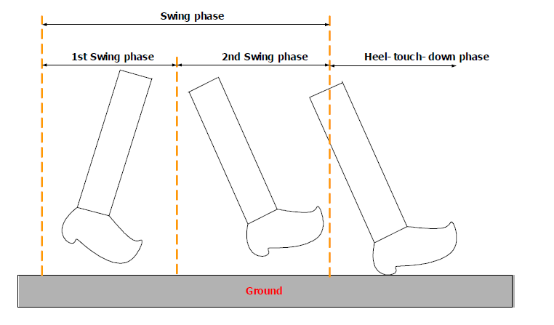
  - (Picture 2.2.2.1 A Step, Stride and Heading Determination for the Pedestrian Navigation System)
Picture 2.2.2.2 below shows the typical three axes, x, y and z (matching vertical, forward and side acceleration) data of the accelerometer in my iPhone during walking, and what conclusion can be judged from this picture. So no matter how the pedometer wears the phone, there is at least one axis data have sharply periodic changes (this picture shows the Y axis changing sharply).

  - Picture 2.2.2.2
Normally, we can calculate a peak value and a bottom value during one step.
And we can use the sum formula to get a diagram below picture 2.2.2.3. As a valid step must have only one peak value and one bottom value.

  - Picture 2.2.2.3

Key algorithms of recording steps

Peak Detection Algorithm
Four Basic Conditions can be used: (the frequency of thedata caught in this chapter is in 50Hz)
1.Current point is going down.(The Red Point in the following diagram)
2. The previous point is going up.(The Black Point)
3. At least going up twice before coming to positive peak.(The pink lines).
4. The value of the positive peak should be bigger than 1.5g
And we can go on to understand this algorithm by referring to the following diagram.

Transform Domain Algorithm
One condition can be used to exclude invalid data.
1. The duration of two effective adjacent peaks must be longer than 0.2S and shorter than 2s. (Based on common sense)

So we can see the two red peak values are invalid using this algorithm.

Threshold Filtering Algorithm
Two Basic Conditions:
1. The current peak value minus the last valley value must be bigger than the threshold.
2. The Threshold is Dynamic and related with different walking patterns. (There is one red peak datum being filtered.)
The following diagram can be an example for this algorithm.

Pattern Recognition Algorithm
One regulation is:
For examples:(the walking patterns)
- Walking, phone in pocket.
- Walking, phone in hands.
- Walking, phone beside ear.
- Running, phone in pocket.
1. In different patterns, you can see the distinction of the wave variation of accel value from the picture on the right. The following diagram shows the difference between the pattern of walking with the phone in the pocket and the pattern of running with the phone in the pocket.

My pedometer program

The program operation
To run this program showed in follow picture, you can get the exact steps and the accuracy of steps calculation. How to use this program to calculate the steps, there are two procedures below should be done :
- Fill out the path of excel file of Accelerometer data and the test frequency before click Running.
- Fill in the exact count steps in the Exact Steps, and click Calculating.

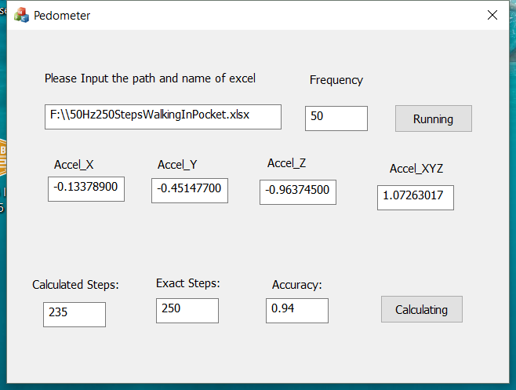

The accuracy of results
We can get the accuracy of this program and this algorithm showed in following form. Of course, there is not the most accurate program or algorithm, and the purpose is to show the method for calculating steps.
Action pattern | Placement of Iphone | Height | Weight | Age | ground condition | Frequncy | Number of step (exactly) | number of steps(by program) | Accuracy
Walking | in pocket of pants | 173cm | 60 Kilo | 28 | Flat | 25Hz | 150 | 250 | 0.6
Walking | in pocket of pants | 173cm | 60 Kilo | 28 | Flat | 50Hz | 235 | 250 | 0.94
walking | in hand(Natural Vertical) | 173cm | 60 Kilo | 28 | Flat | 50Hz | 243 | 258 | 0.94
Walking | Put the Phone Beside Ear (to answer the phone call) | 173cm | 60 Kilo | 28 | Flat | 50Hz | 192 | 250 | 0.77
Running | In pocket of Pants | 173cm | 60 Kilo | 28 | Flat | 50Hz | 258 | 250 | 0.97

Gyroscope with balance racing game

The introduction of Gyroscope

What is a gyroscope
Wikipedia explains : “gyroscope is a device used for measuring or maintaining orientation and angular velocity ”Exactly, gyroscope is often used to detect the orientation that has similar function with compass. Nowadays the gyroscope becomes more and more popular and it has many applications such as used in inertial navigation systems and gyrocompasses.
The most popular application is to be installed in the mobile phone. For example, it can work together with GPS in phones to help people navigate easier and more precise.

Working principle of a gyroscope
There are different kinds of gyroscopes, such as MEMS gyroscope、fibre optic gyroscope and the sensitive quantum gyroscope. Different types base on different principles of operation, and in this thesis, we just introduce the working principle of the most popular one used in iPhones.
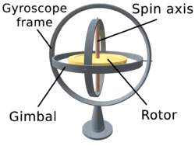
  - (Picture 3.1.2.1 Wikipedia)
As you can see from picture 3.1.2.1 above, there is a Rotor which can spin freely 360 degrees around a Spin axis in a Gyroscope frame and a Gimbal. This is a basic frame of the Gyroscope and the angular velocity in each direction can be detected by the free rotation of the rotor.

There is another picture below, Picture 3.1.2.2, there is a clear space match between the gyroscope frame and coordinate graphs. Based on angular momentum the Rotor resists to changes in orientation, thereby allowing to measure the changes of the angles. The rotation or the angle changes in different directions or positions will affect a change of resistance of a gyroscope and in this way, we can calculate the angular velocity in those three-axes orientations, so this is a basic principle of how the gyroscope works.
  - (Picture 3.1.2.2 Gyroscope Principles)

The relationship between Gyroscope and Accelerometer
At first, it is clear that those two devices have different functions: gyroscope sense the rotation, whereas the other is used to test the accelerometer, so the restriction of functions in two devices decides that they often have to work together.
There is an example to clarify the different function they work. When an aircraft fly in the sky, the accelerometer can used to test the change of movement. So when an aircraft fly too fast in suddenly, the accelerometer can remind the pilot of the unsafety of sudden change of the speed. However, when the aircraft has some faults with an unsafe shake around itself, here the accelerometer can sense it, but the gyroscope can detect the any rotation of the aircraft to notice the pilot of the insecurity.
Through this example, we can further understand that they are totally different, but they can also make up for each other to achieve some functions.

The racing game with Gyroscope

How a gyroscope works in iPhone
Depending on the base of working principle of gyroscope, we continually discuss how a gyroscope works in a smart phone, here, using iPhone as an example to describe. The three-axis MEMS gyroscope showed in picture below is often chosen by iPhone.

Absolutely, a gyroscope must be used to test the angular velocity or the orientation, so here we only need to solve two questions:
- How to judge the current orientation of movement.
- How to get the correct angle of the phone in every axis.

Get the current orientation of movement of the phone.
There is a Picture 3.2.2.1 below showing the position of the gyroscope chip of the iPhone in the centre of the coordinate axis with three direction axes: roll, pitch and yaw (x, y and z), and they are (almost) 0 degrees.
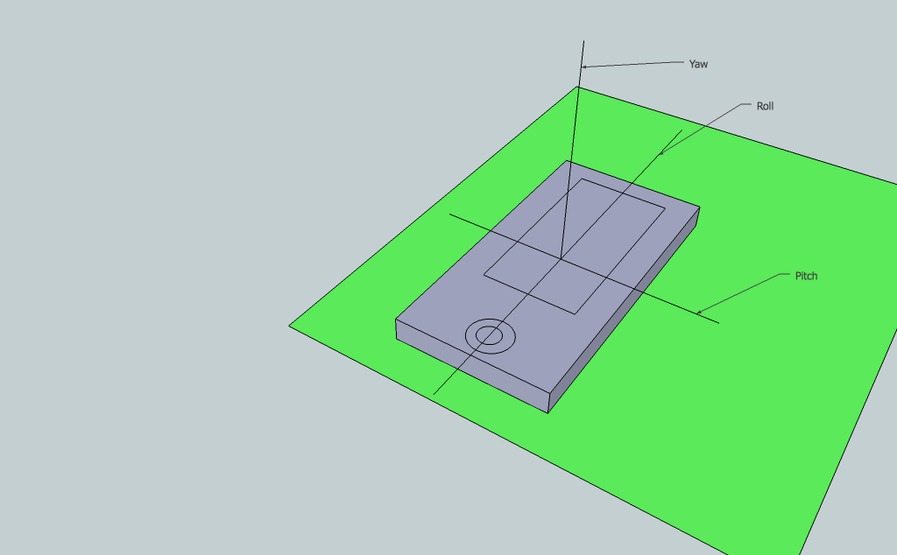
  - (Picture 3.2.2.1 Gyroscope in iPhone)
Here, when we try to rotate the phone up and down several times only along roll (x) axis, it will produce a change of the angular velocity showed in the form below. It is clear that there is almost only one orientation data change happened on Roll (x) axis. And what the information we can summarise is that any orientation the rotation happens it will cause the angular velocity on the corresponding axis.

So we can judge the orientation of current movement through the angular velocity, if there is the angular velocity in one axis, it means the phone is rotating or moving in that direction and if the value is positive, that means the phone is moving forward, vice versa.

Calculating the current angle in every axis
Before for calculating the current angle, we must be clear for two functions of the basic mathematics here. I believe everyone has studied them during high school or university Physics and Math lessons.
One of them is 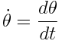, what this function doing is to describe how to using the angular velocity to get the angle change during a period.
Since we can get the angle in a specific period using the function above, in the next step we need to think how to get the absolute angle in any time.
Therefor another function should be mentioned here: 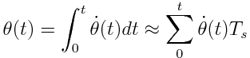
What function does is using the integral principle to integrate the angular velocity in all the period from time 0 ( t = 0) to get the absolute angle. The last approximation part equitation is because of the angular velocity change faster than a gyroscope gets. And also because the drift happens all the time, this function for calculating the angle is impossible and just a the theoretical assumption.

How a gyroscope works for the racing game



Glow Stick with Accelerometer and Gyroscope

